Stems
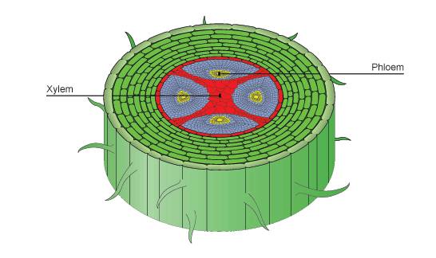
You will need:
1 Jar – lid removed
water
Celery
Carrots
Paper Towels
1 Plastic straw
1 Wooden Dowels 8-10” in Length, ½” diameter
1 Carnation Flower
Food coloring
Stem Investigation Sheet
Magnifying lens

Directions
- Choose a jar
- Add water and several drops of food coloring to the jar.
- Add a flower, a stem of celery, a straw, a strip of cut paper towel, and a wooden dowel to each jar.
- Fill out the Stem Investigation Sheet. Predict what will happen with each “stem”.
- Predict how the colored water would affect the stems overnight.

